EGERTON UNIVERSITY

USER MANUAL FOR

DIGIVERSE BUSINESS ADVERTISING PLATFORM

PREPARED BY:

NAME: JIM MUGUNA KAREMU

REG NO: S13/03153/18

PROJECT SUPERVISOR: Mr. OMWOYO

PROJECT CORDINATOR: DR. BOSIRE

TABLE OF CONTENTS

1.0 GENERAL INFORMATION 2

1.1 System overview 2

1.3 Points of contact 2

2.0 SYSTEM FEATURES 3

2.1 Login 3

2.1.1 Login 3

2.1.1.1 Unregistred user view 3

2.2 SIGN UP 8

2.3 Reset Password 8

3.0 COMPANIES 11

3.1 Listing a Business 11

3.2 View Business Profile 12

3.3 Contact Business 13

3.4 Like and Follow Business 14

4.0 CATALOG 15

4.1 View Catalog 15

4.1 Manage Catalog 16

5.0 ADS 18

5.1 Manage Ads 18

# **1.0 GENERAL INFORMATION**

## **1.1 System overview**

The "Digiverse Business Advertising Platform" is a project that connects businesses with potential customers by allowing businesses to list themselves and providing details about their services. Users can view and review businesses, search for jobs, catalogs, posts, and other features. The platform may include a search function, user accounts, business profiles, reviews and ratings, catalogs, job postings, and a feature for businesses to post updates and announcements.

**1.2 Authorized use permission**

The Digiverse Business Advertising Platform is available to the public. Every business that adopts this platform will however be required to cutomize their profiles by providing some information about themselves.

## **1.3 Points of contact**

For additional information, please contact the developer through the contacts below:

Email – mugunajim@gmail.com

Phone Number – 0729825703

WhatsApp – 0729825703

# **2.0 SYSTEM FEATURES**

## **2.1 Login**

### **2.1.1 Login**

Logging in is not a requirement to access the platform. However not logging in limits the functionalities that someone can access. To login:

1. Open web browser and navigate to the Digiverse Business Advertising platform.
2. Click on the login menu

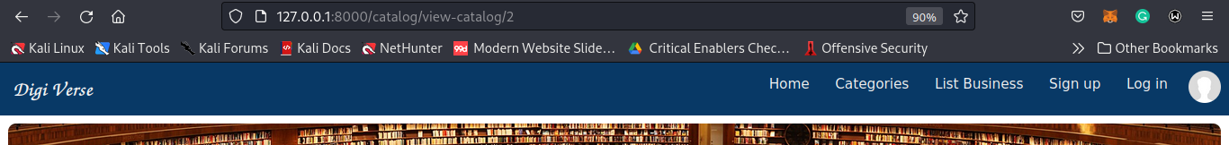

1. A log in form appears as shown below

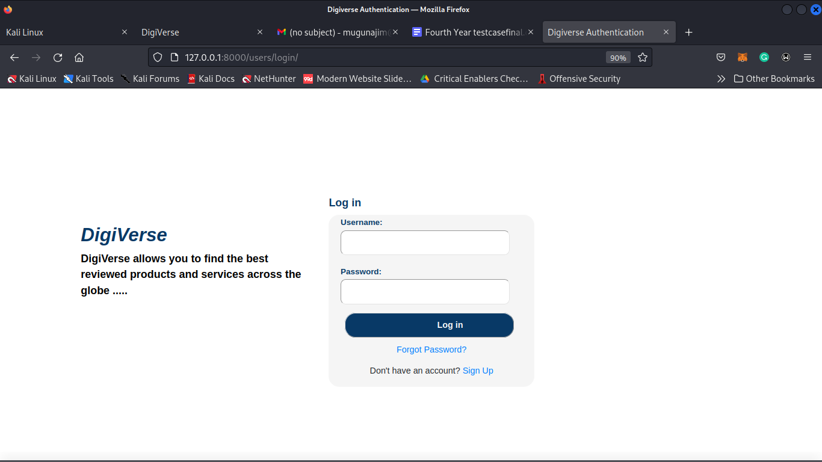

1. Enter the username and password and click the LOGIN button. Users create passwords during registration.

#### 2.1.1.1 Unregistred user view

1. Unregistred users landing page looks like this

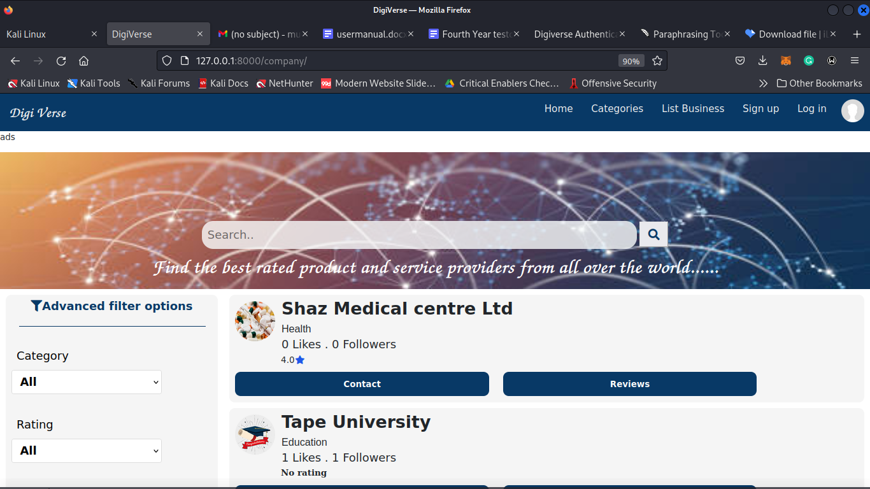

1. Pressing any business

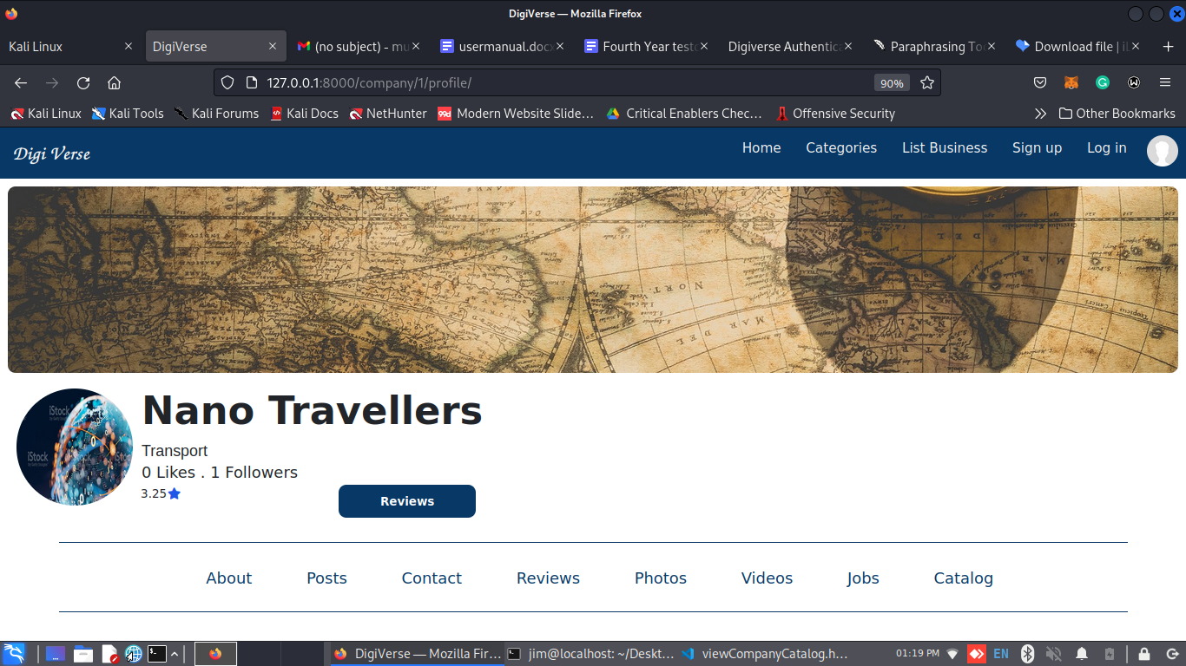

1. Pressing about

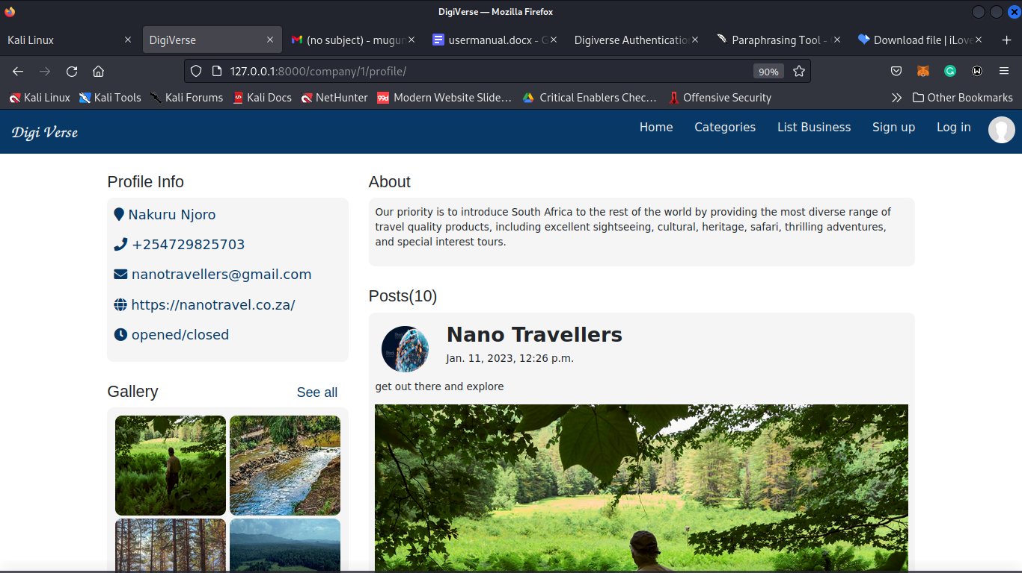

1. Pressing Posts

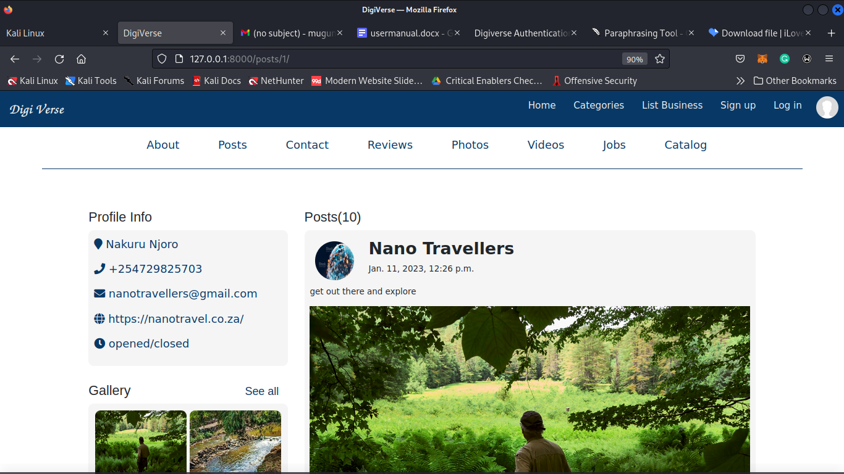

1. Pressing Reviews

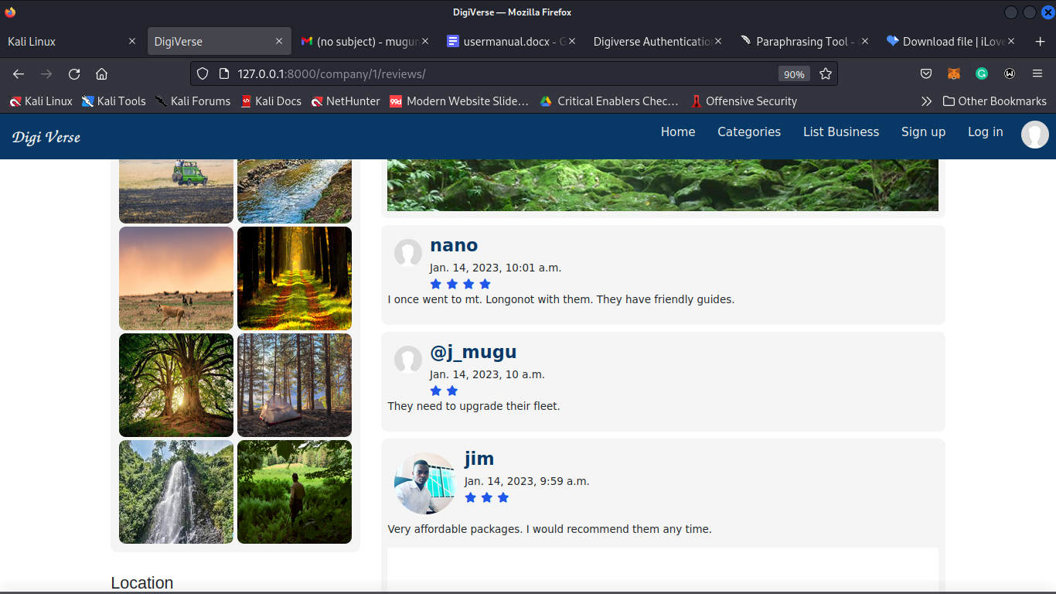

1. Pressing photos

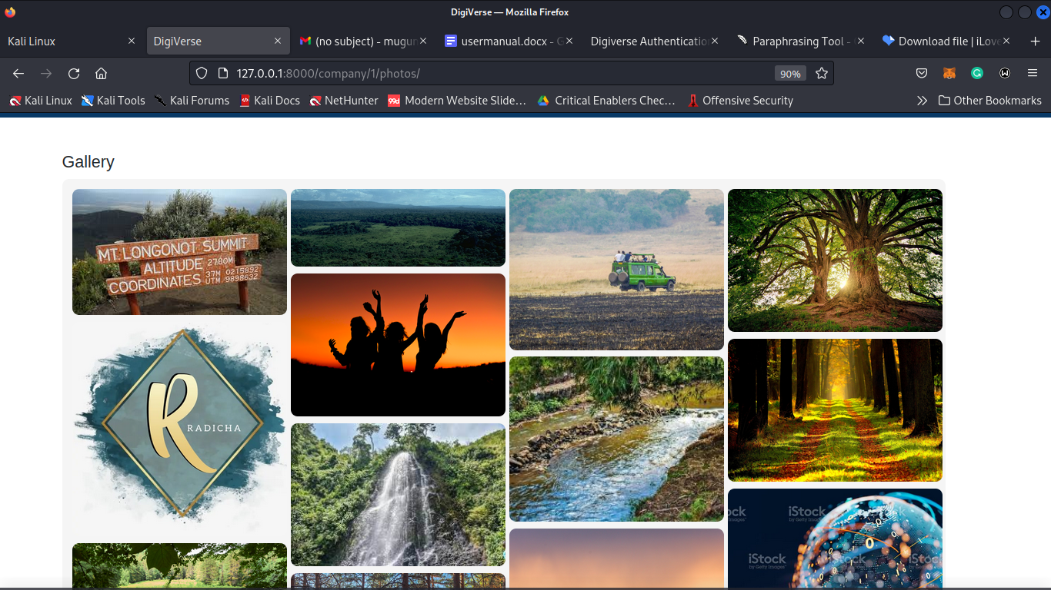

1. Pressing Jobs

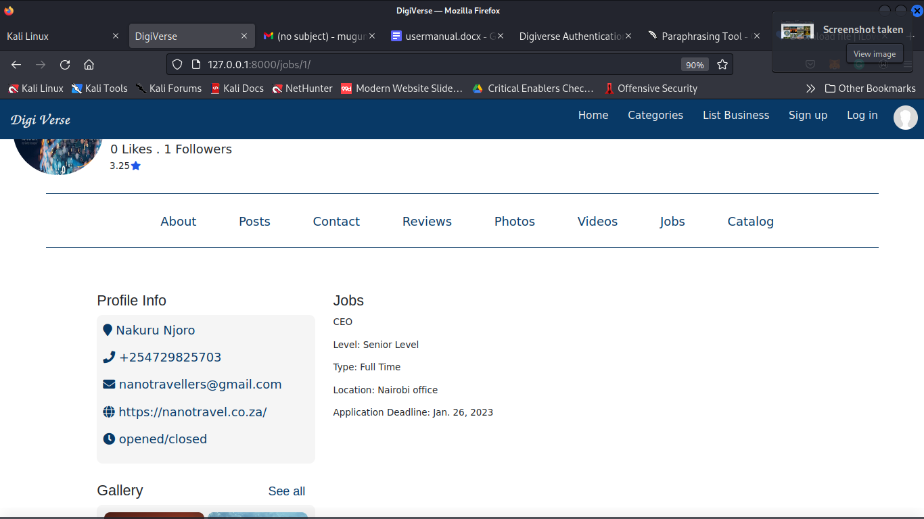

1. Pressing Catalog

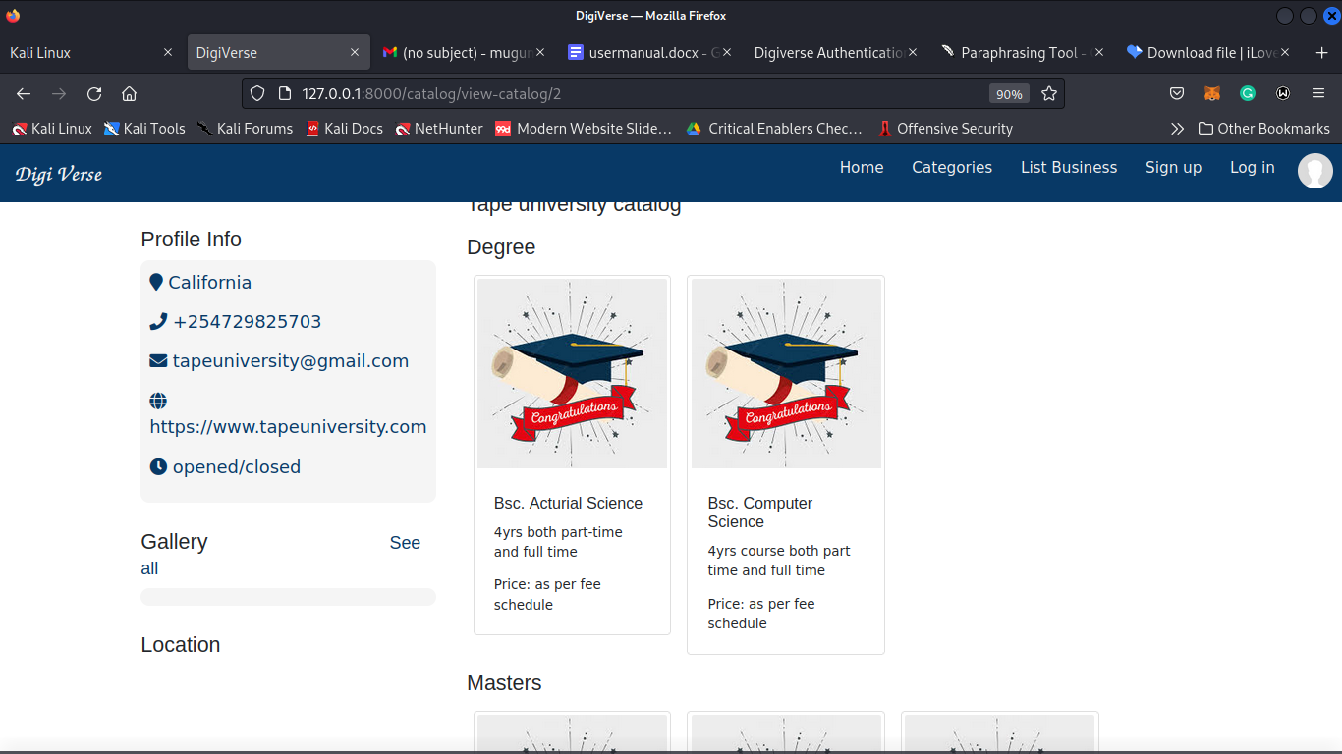

# 

## **2.2 SIGN UP**

1. To signup click on signup button on navbar



1. Fill in the user details including the username, email, names, phone number, profile picture and password.

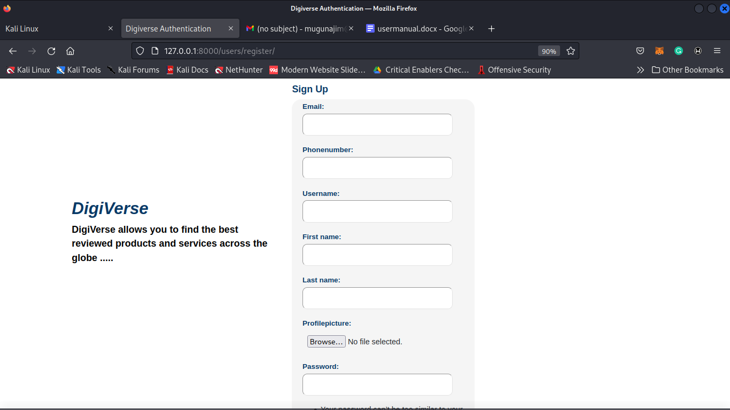

1. click on the signup button

## **2.3 Reset Password**

1. On the login page click on forgot password



1. Then enter your email address to receive a password reset link

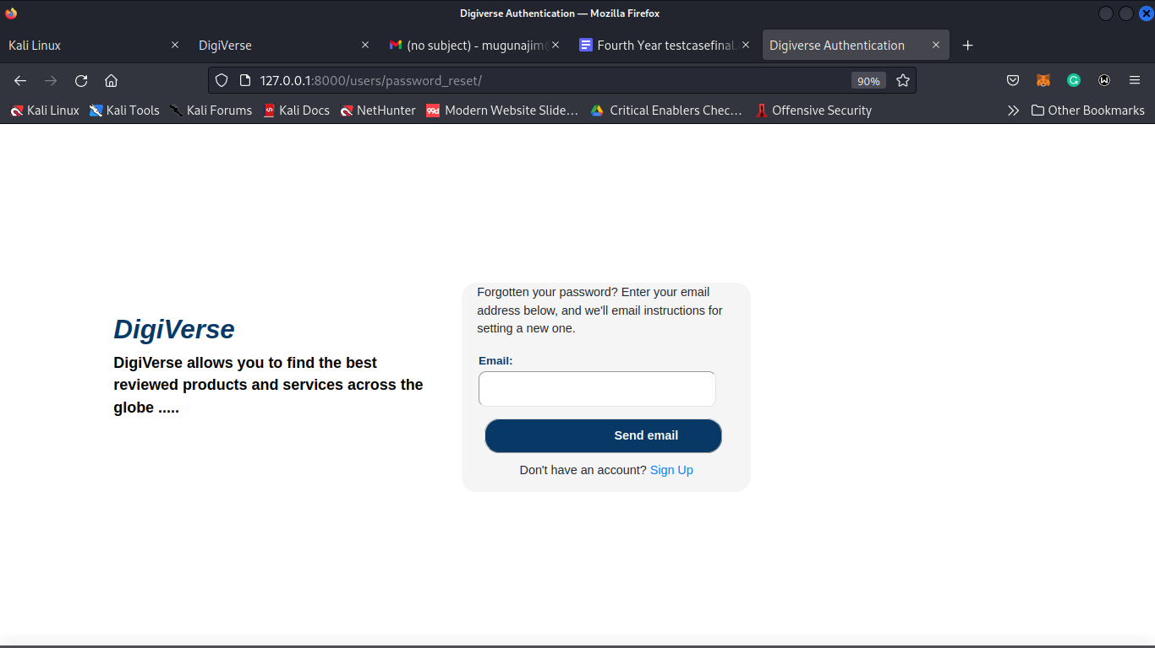

1. Click on send button

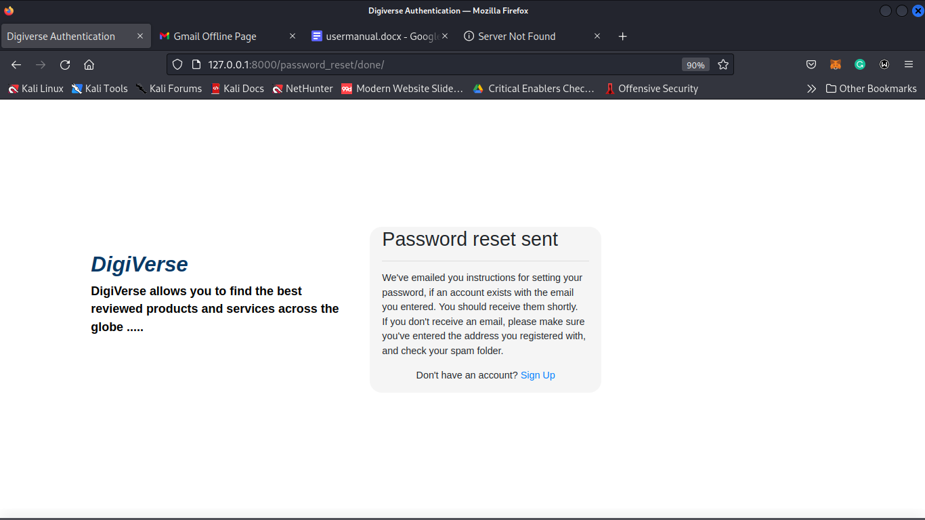

1. Click the link sent to your email, supply a new password then click reset password.

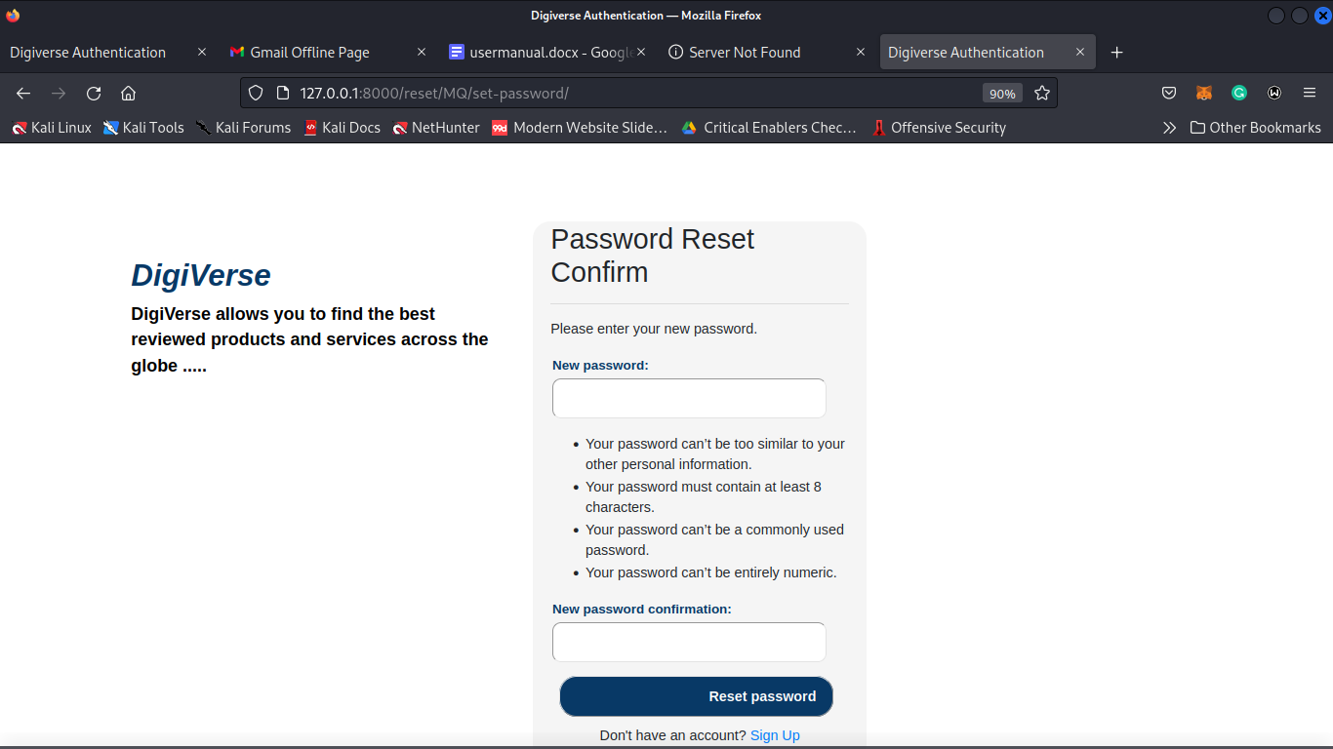

# **3.0 COMPANIES**

## **3.1 Listing a Business**

Only registered and logged in users can access this functionality.

1. Once you are logged in, click on the “List Business” button on the navigation bar



1. Supply business information on the form.

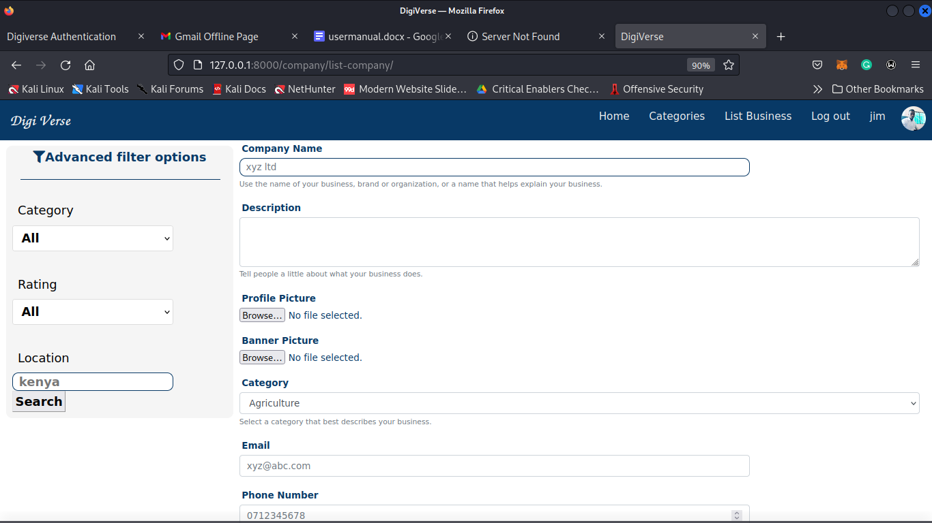

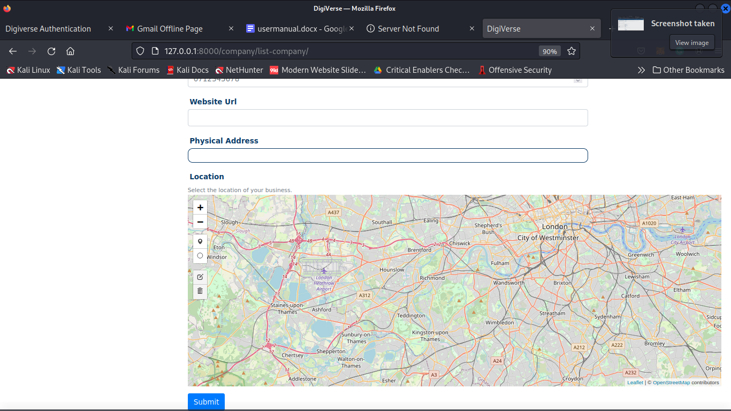

1. Click on submit button. You’ll be redirected to the business profile page

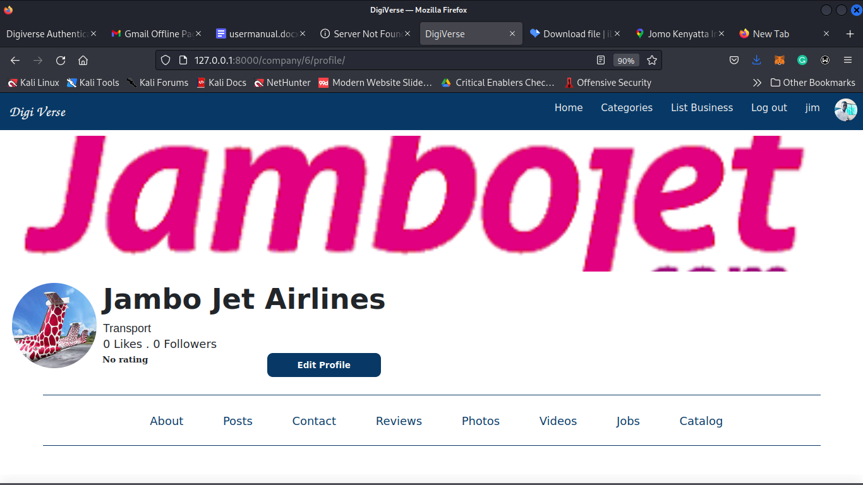

## **3.2 View Business Profile**

To view a business’ profile you just need to click on the business from the home page. You can find a business by searching it or by using the advanced filter.

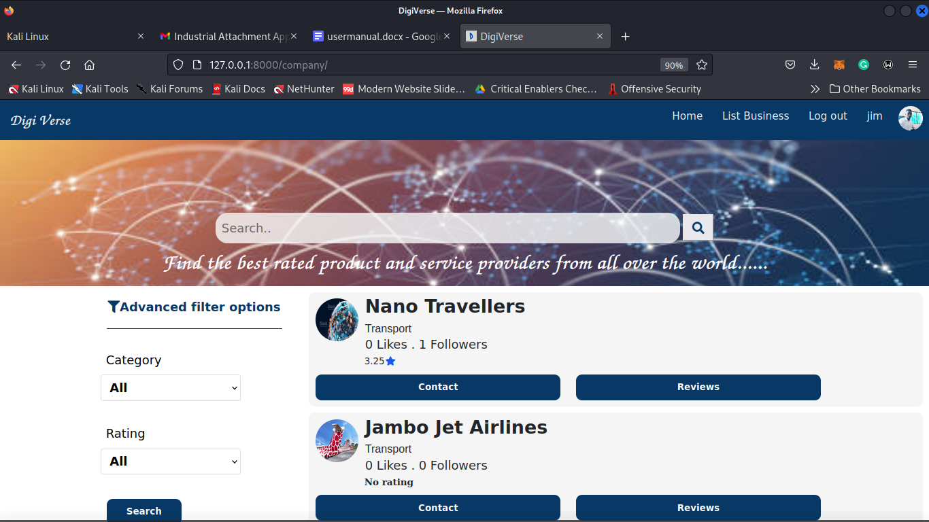

Clicking on “Nano Travellers” will take you to it’s profile.

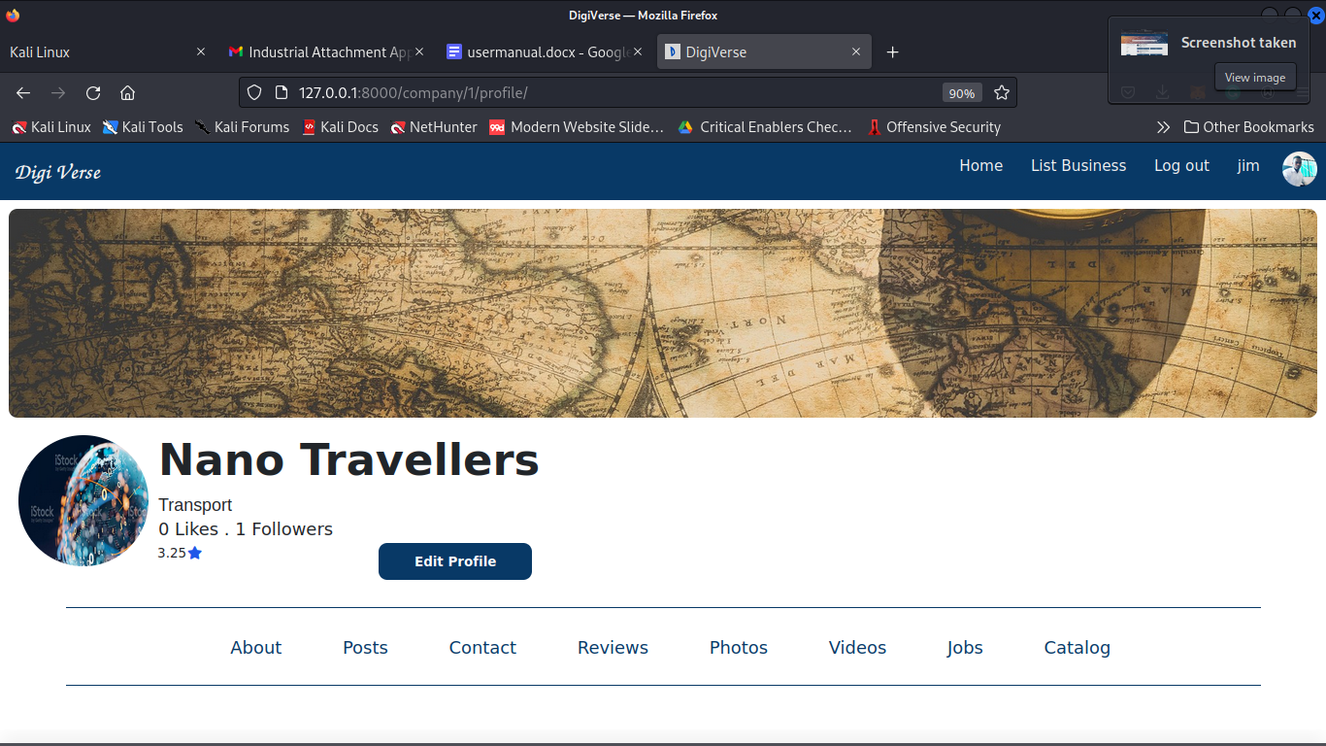

## **3.3 Contact Business**

From The business profile page, you can find the business contact information listed on the left side.

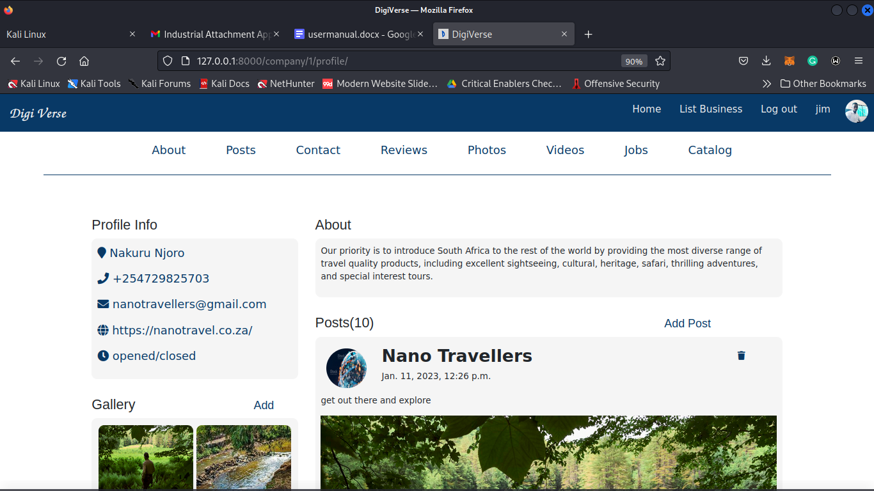

You can also click on the “Contact” tab from the business profile menu to send an email to the business via the platform.

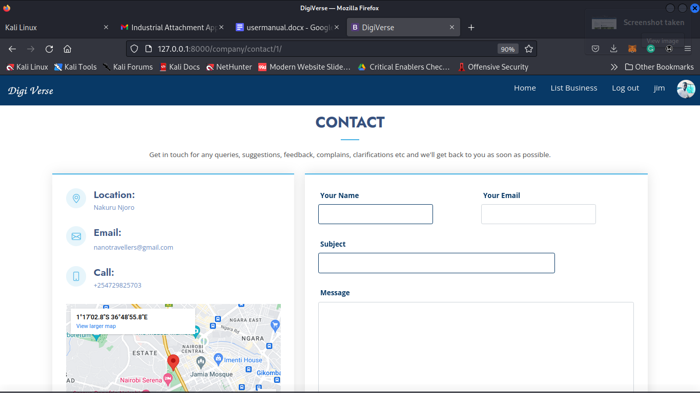

## **3.4 Like and Follow Business**

To like or follow a business just click the like or follow name under each business name. To undo these actions just click again.

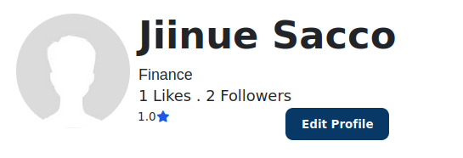

# **4.0 CATALOG**

## **4.1 View Catalog**

1. Visit the business profile page

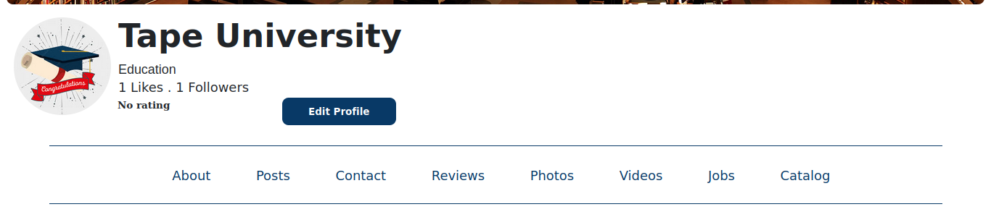

1. Click on catalog

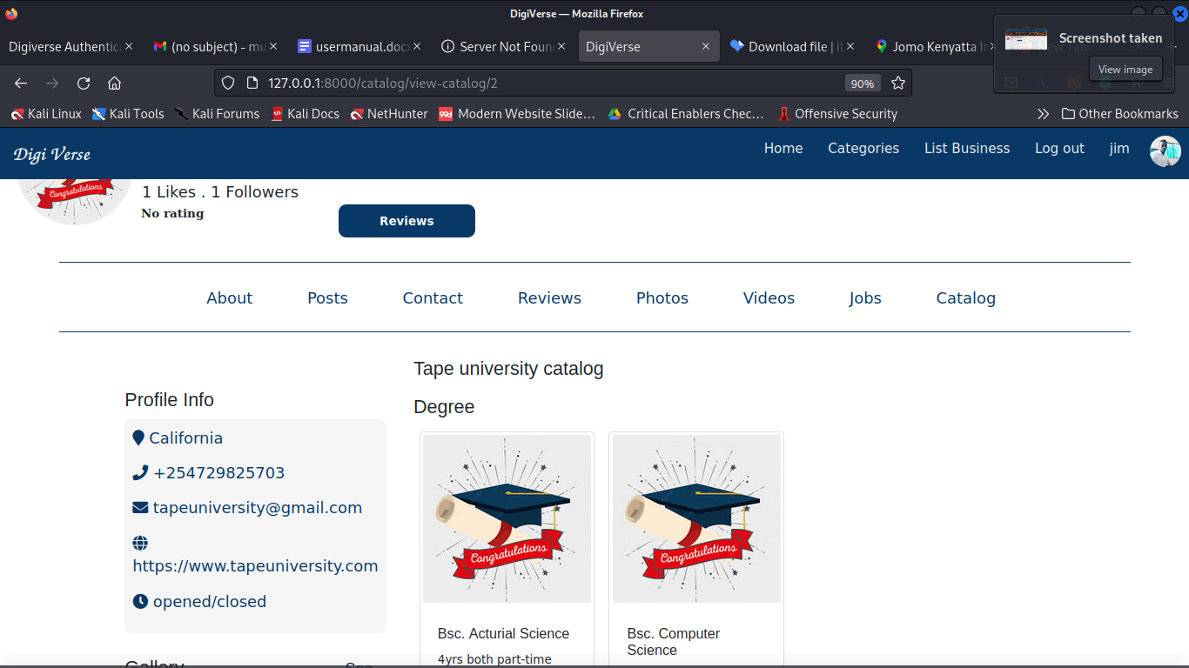

## **4.1 Manage Catalog**

The catalog can only be managed by the business admin only. To do this, ensure that you are logged in, then click on your username on the top right corner of the navigation bar. This will take you to the business admin dashboard.

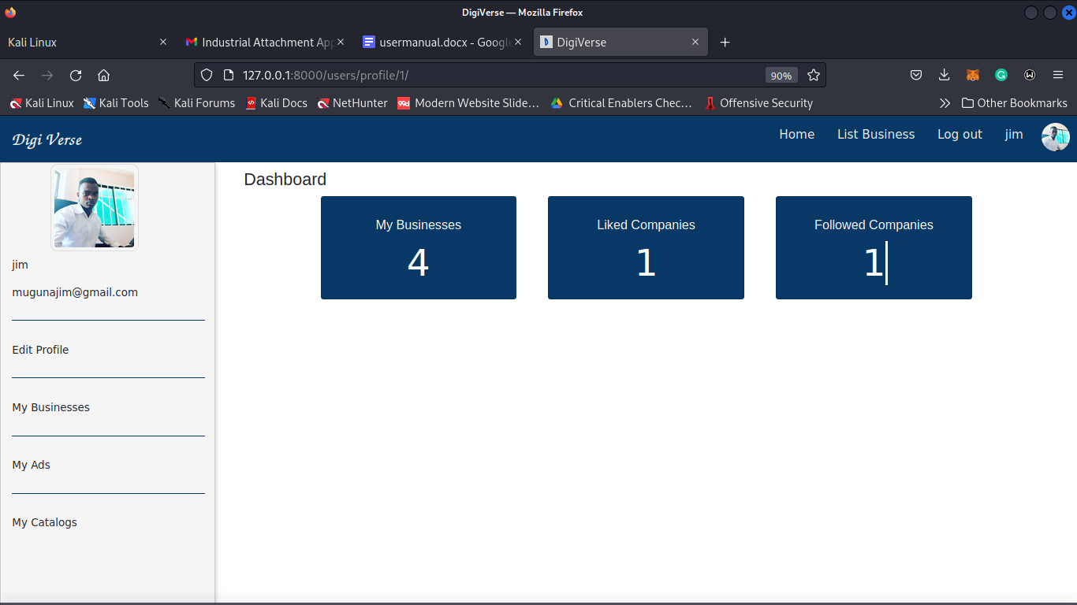

From the dashboard screen, click on the “My Catalogs” tab.

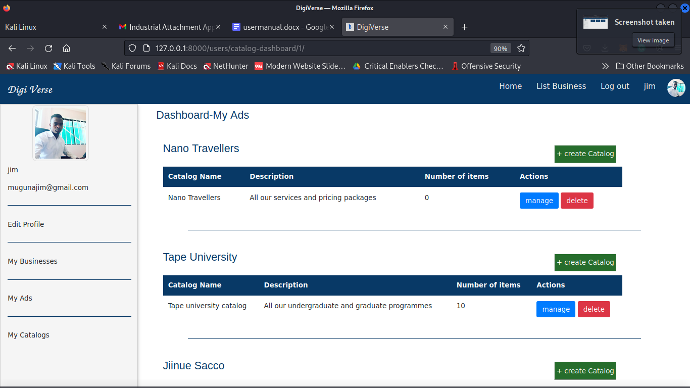

This will display all the catalogs for each of your business. From here you can create new catalogs for each business and also delete catalogs.

To manage catalogs click on the “manage” button for the target catalog.

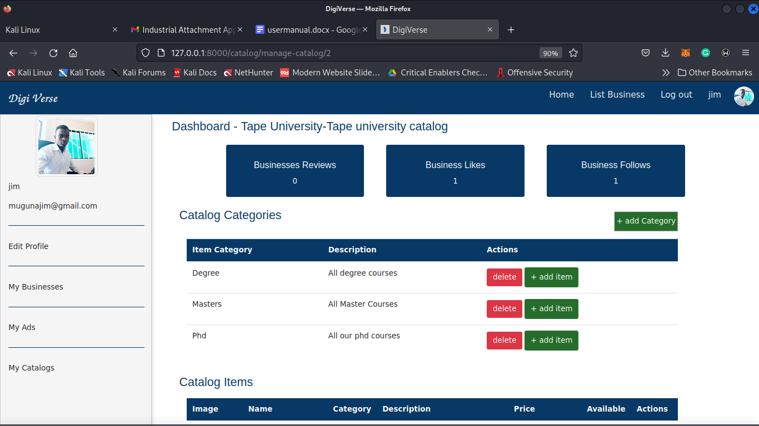

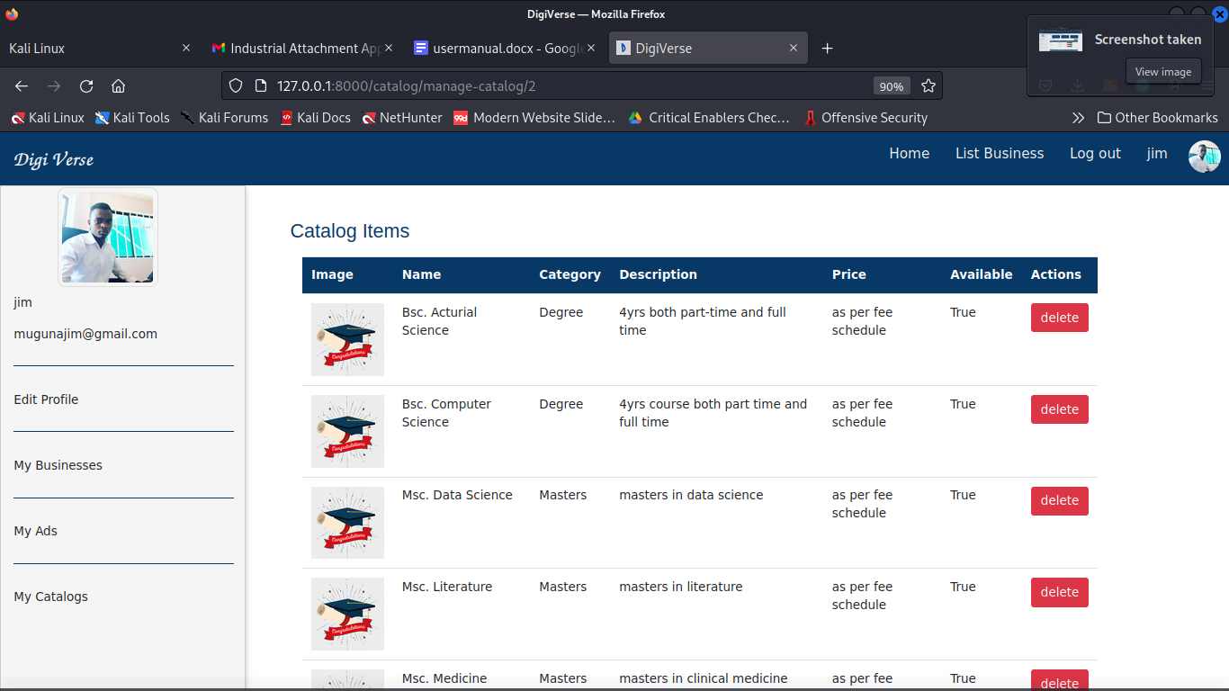

From here you can create new catalog categories and add or remove items from the catalog.

# **5.0 ADS**

The platform displays ads on different places within the platform. The ads appear at random. Clicking on any ad will redirect to that Business’ profile.

## **5.1 Manage Ads**

This functionality can only be accessed by the business admin. To access the ad management module, click “My Ads” tab from the menu on the left.



Clicking “My Ads” tab:

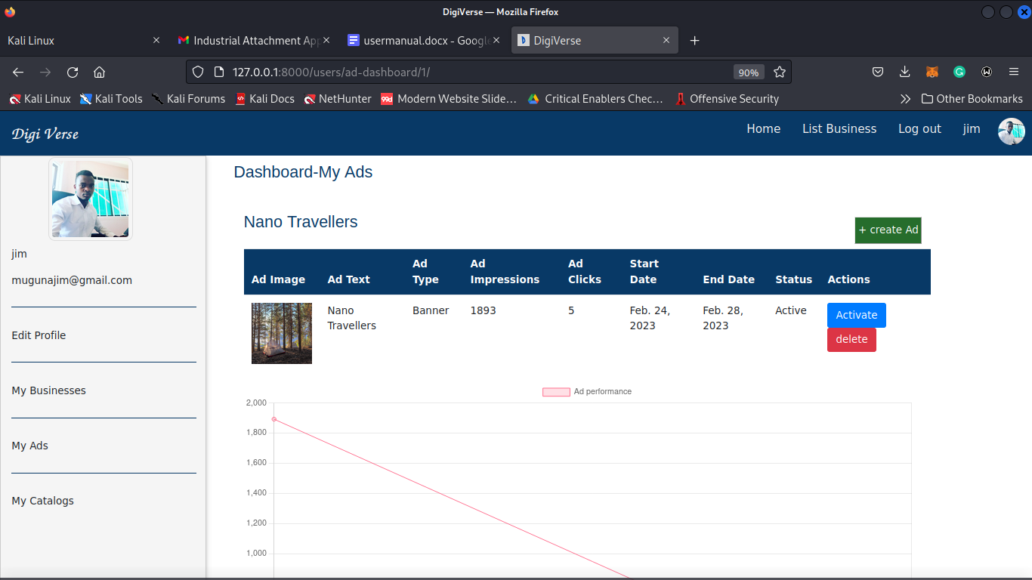

From here you can view how your ads are performing in terms of impressions and click. You can also create new ads, activate ads (pay for the ads) and also delete the ads.